**Sonar Ideas / Design**

Current Sensor Holders for TurtleBot:

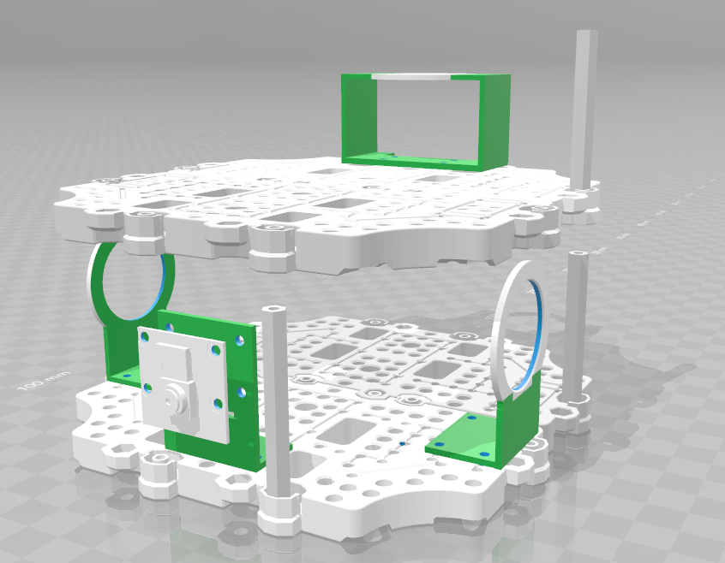

Design for 6 Total Sonar Sensors on TurtleBot:

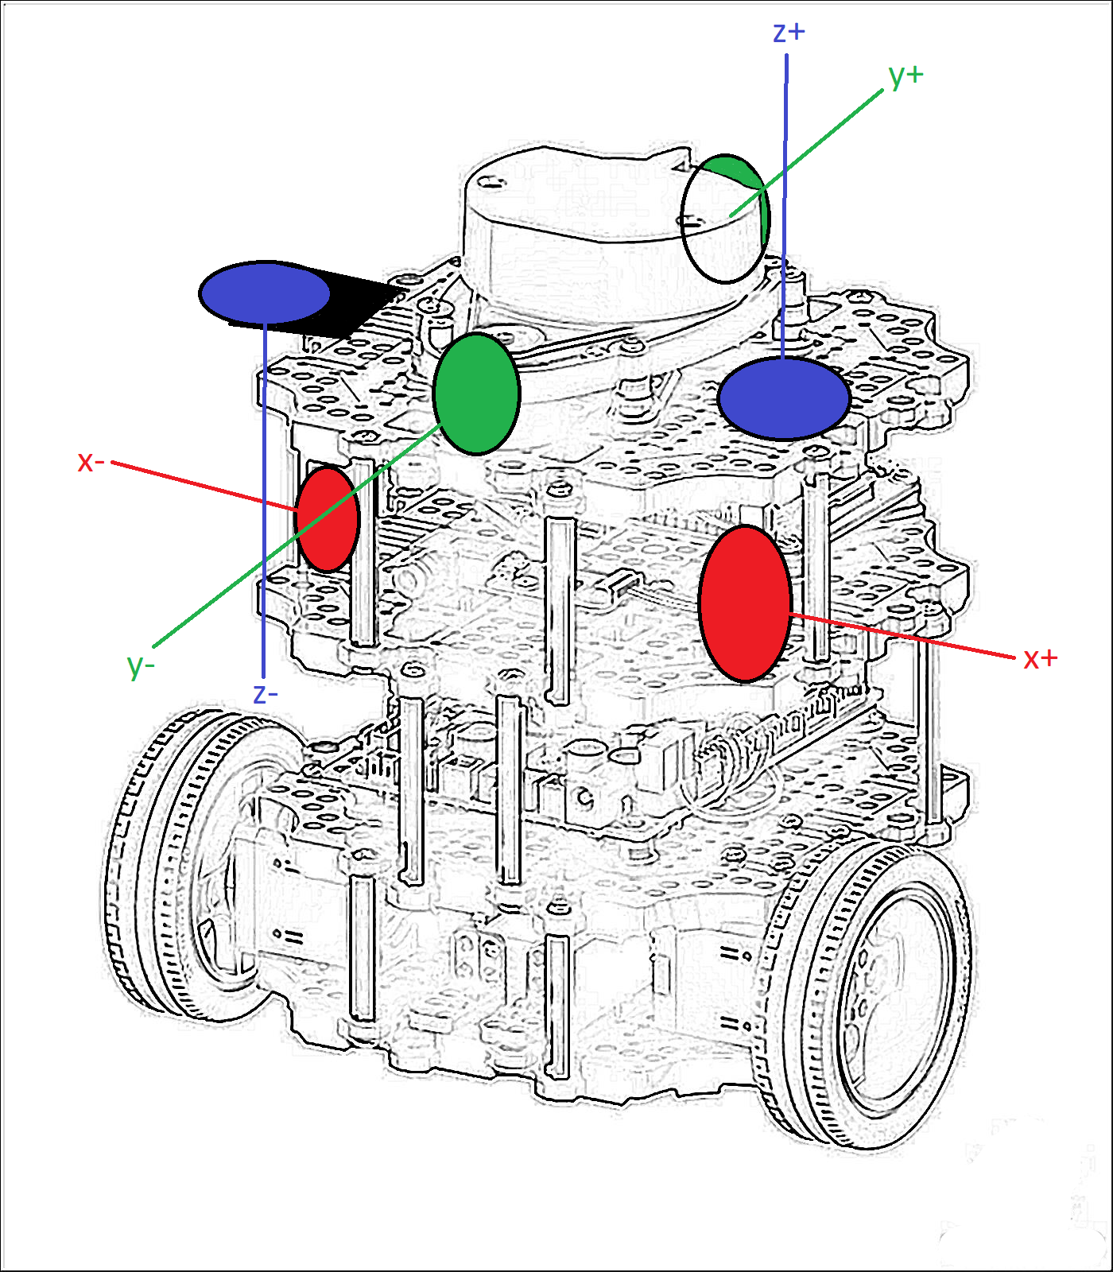

Design for 6 Sonar Sensors on G2X Submarine:

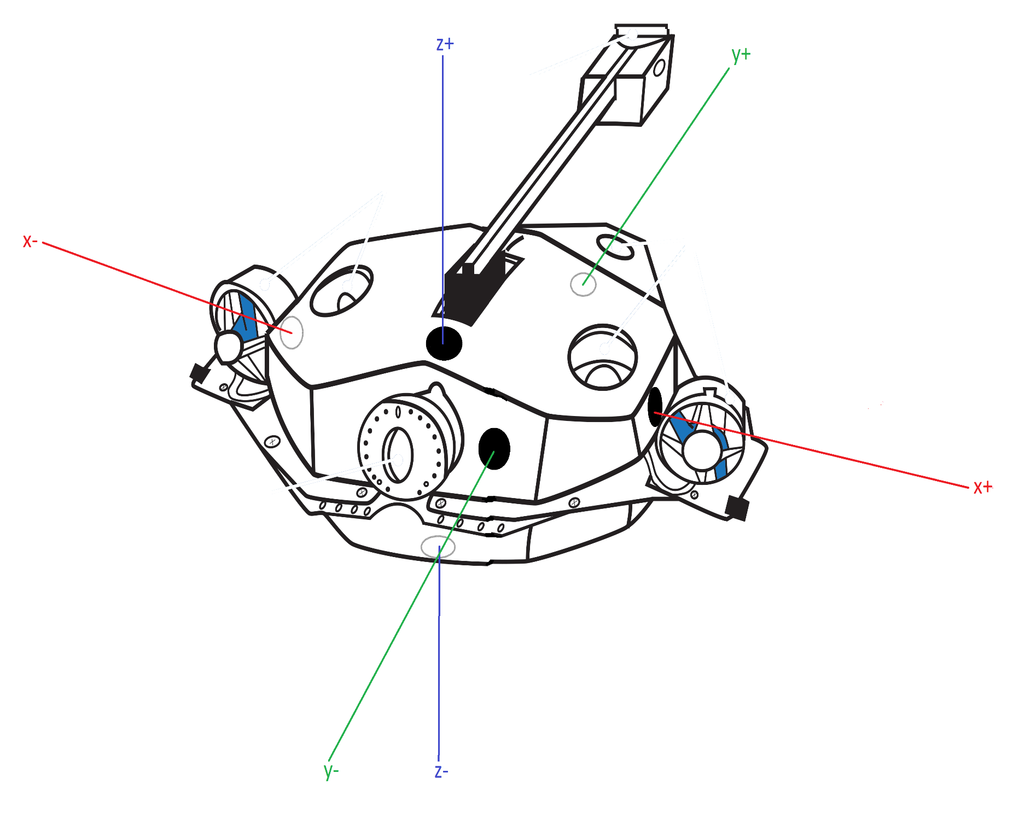

Sonar Mapping:

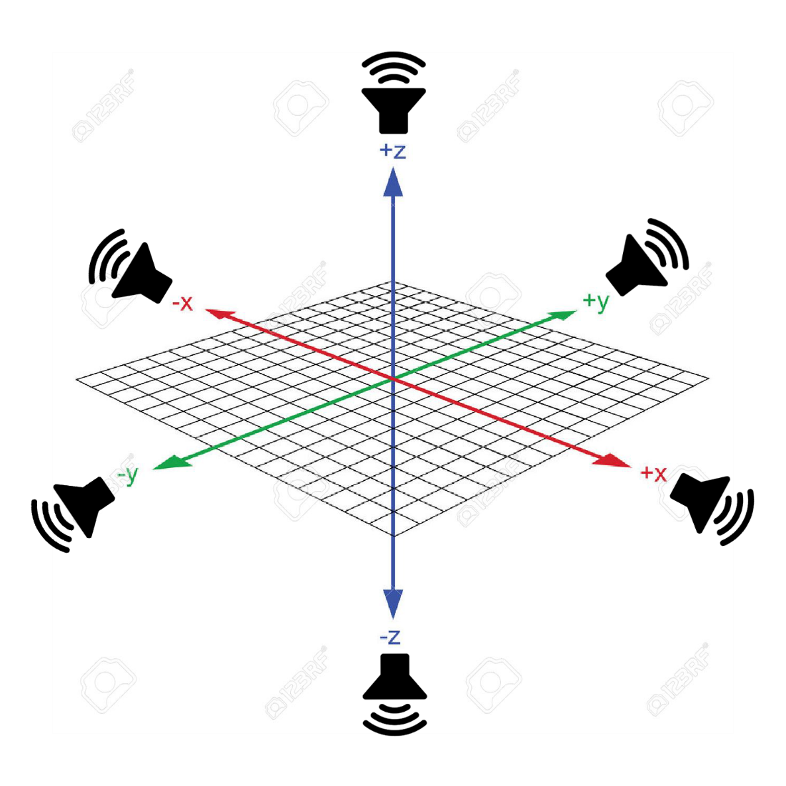

Sonar Object Detection: Matbotix 765cm (25ft)

